

**THE CATHOLIC UNIVERSITY OF EASTERN AFRICA**

**PROJECT PROPOSAL FOR FINAL YEAR STUDY IN**

**BACHELOR DEGREE OF SCIENCE IN COMPUTER**

**SCIENCE**

**BY**

**BEN GITHUA NG’ANG’A**

**CAR PARK MANAGEMENT SYSTEM AT THIKA ROAD MALL**

**DECEMBER, 2024**

SUBMITTED IN PARTIAL FULFILLMENT OF THE REQUIREMENTS FOR THE AWARD OF DEGREE OF BACHELOR OF SCIENCE IN COMPUTER SCIENCE IN CATHOLIC UNIVERSITY OF EASTERN AFRICA

# **DECLARATION AND APPROVAL**

**Student**

I Ben Githua Ng’ang’a declare that this project is my original work and has not been presented in any other university or institution for academic credit.

Signed _________________ Date __________________

**University Supervisor Approval**

This project proposal has been submitted for examination with my approval as university supervisor.

Signed _______________ Date ________________

Mr. CHRIS NANDASABA

Faculty of Science

**University Head of Department Approval**

Signed ___________________ Date ____________________

Mr. Michael Kinyua

H.O.D of Faculty of Science

# ACKNOWLEDGEMENT

I would like to thank the Almighty God for giving me the strength to undertake this project and giving me ideas that have made me accomplish it. I also thank my family for being supportive throughout the entire project.

I would like to thank my supervisor, Mr. Chris Nandasaba for his guidance and support through the entire project. My gratitude is with you always.

# DEDICATION

I thank my Family as without their support this degree and where I have reached would not have been a reality. I would dedicate it also to all Technological folks who would love to see our country moving to next level of technological advancement.

# ABSTRACT

*Car parking management remains effective in malls, where high vehicle turnover and congestion during peak hours challenge operational efficiency and customer satisfaction. This paper introduces the state-of-the-art car parking management system tailored for malls. Advanced technologies are integrated to streamline parking operations, optimize space utilization, and improve the user experience. Entry and exit in the proposed system have been automated using RFID tags, recognizing license plates, allowing vehicles to get in smoothly with little human intervention. Real-time occupancy sensors were mounted at strategic locations around the facility to provide dynamic information regarding available space for efficient parking allocations. The system will be flexible with various payment methods like cash, mobile applications, and contactless card payments for convenience to visitors. Security and compliance are ensured with strong data encryption protocols that protect user information and payment transactions. The system will also be integrated with traffic management systems and smart signage to enhance vehicle flow within the parking area of the mall and reduce congestion. The system, which is developed in Visual Basic.NET and an online Firebase Database, applies the Waterfall methodology. This ensures that the flow of data is clear and operations are available. Data were collected through observation, mapping, surveying, and interviewing to design the system. Testing of the system and training of drivers is recommended for smooth implementation and functionality at a mall. This system promises to enhance parking operations in malls by offering a secure, user-friendly, and efficient way of addressing the modern parking challenge.*

**TABLE OF CONTENTS**

DECLARATION AND APPROVAL ii

ACKNOWLEDGEMENT iii

DEDICATION iv

ABSTRACT v

LIST OF FIGURES viii

LIST OF TABLES viii

DEFINITION OF KEY TERMS ix

**CHAPTER 1: INTRODUCTION** 1

**1.1** **Introduction** 1

**1.2** **Background of the study** 1

**1.3** **Problem Statement** 2

**1.4** **Main objective** 2

**1.5** **Specific objective** 2

**1.6** **Justification** 2

**1.7** **Scope of the proposal** 3

**1.8** **Proposal Organization** 3

**1.9** **Chapter summary** 4

**CHAPTER TWO: REVIEW OF RELATED WORK** 5

**2.1** **Introduction** 5

**2.2** **Methodology of Literature Review** 5

**2.3** **History of the research** 6

**2.4** **Review of Related Prototypes and Systems** 7

**2.4.1** **Tuskys Parking Management System** 7

**2.4.2** **Westgate Shopping Mall Parking System** 8

**2.4.3** **Automated Robotic Parking System** 9

**2.4.4** **Smart Car Parking System** 9

**2.4.5** **Car Parking: Impacts, Policy and Practice** 10

**2.5** **Emerging Trends and Patterns in the research** 10

**2.6** **Research gap filled by the research** 11

**2.7** **Chapter Summary** 11

**CHAPTER 3: RESEARCH METHODOLOGY** 12

**3.1** **Introduction** 12

3.2 **Methodology for Requirement Elicitation** 12

**3.2.1** **Requirement Specifications** 12

**3.2.2** **Data collection and Analysis Techniques** 14

**3.3** **Methodology for system analysis** 14

3.3.1 Data Flow Diagrams 15

**3.4** **Methodology for system design** 20

3.4.1 Work flow diagram 20

3.4.2 Database Design 21

3.4.3 Sequence diagram 21

3.4.4 Collaboration diagram 22

**3.4.5** **Pseudo code diagram** 23

3.4.6 Early system prototypes 24

**3.5** **Methodology for System Implementation** 24

**3.5.1** **Back-end Technologies** 24

3.5.2 Front-end Technologies 25

**3.5.3** **Databases Technology** 25

**3.6** **Methodology for System Testing** 26

**3.7** **Methodology for System Deployment** 27

**3.8** **Chapter Summary** 28

**4** **CHAPTER 4: SCHEDULE, RESOURCES AND BUDGET** 29

4.1 Introduction 29

**4.2** **Project Schedule** 29

**4.3** **Project Resources** 29

**4.4** **Project Budget** 31

**4.5** **Chapter Summary** 31

**References** 32

APPENDIX 33

QUESTIONAIRE 33

INTERVIEW 34

# LIST OF FIGURES

Figure 1 dfd diagram level 0 15

Figure 2 dfd diagram level 1Figure 3 dfd diagram level 0 15

Figure 4 flowchart diagram 19

Figure 5 work flow diagram 20

Figure 6 database diagram 21

Figure 7 sequence diagram 22

Figure 8 collaboration diagram 23

Figure 9 back end 25

Figure 10 database technology 26

Figure 11 database 26

# LIST OF TABLES

Table 1: Project Schedule 29

Table 2:Project Budget 31

# DEFINITION OF KEY TERMS

**Occupancy Sensors**: Devices used to detect the presence of vehicles in parking spaces, allowing for real-time monitoring of space availability.

**RFID (Radio-Frequency Identification):** Technology used for automatic identification and tracking of vehicles through the use of radio-frequency tags or cards.

**License Plate Recognition (LPR):** Technology that uses optical character recognition to read vehicle license plates, often used for automated entry and exit systems.

**CPMS (Car Park Management System):** a software application that helps manage and control parking in a car park or garage.

**Ticket Dispenser**: Mechanism that issues parking tickets to users upon entry to the car park, often used in conjunction with payment systems.

**Payment Gateway:** Online service that facilitates electronic payments for parking fees, allowing users to pay through various methods such as credit/debit cards, mobile wallets, or prepaid cards.

**Reservation System:** System allowing users to pre-book parking spaces in advance, often via online platforms or mobile applications.

**Dynamic Pricing:** Pricing strategy that adjusts parking fees based on factors such as demand, time of day, or special events, aimed at optimizing revenue and space utilization.

**Integration:** Process of connecting and coordinating different components or systems within the car park management system, such as payment systems, access control systems, and traffic management systems.

**User Experience (UX):** The overall experience and satisfaction of users interacting with the car park management system, including factors such as ease of use, convenience, and effectiveness.

# **CHAPTER 1: INTRODUCTION**

## **Introduction**

With the increasing number of vehicle owners, with more than 44% of the population owning cars, there is an urgent need to ensure proper parking solutions in urban areas. Busy locations like Thika Road Mall face significant challenges in parking management, leading to congestion, wasted time, and reduced productivity. Studies have shown that as much as 38% of peak-hour traffic around Thika Road mall is caused by drivers searching for parking spaces, which inconveniences motorists and negatively impacts businesses by reducing customer access to shopping centres and restaurants (Smith & Johnson, 2020). Implementing a digital system where drivers can assess available parking spaces and navigate to one suitable for them would streamline parking operations. Such a system would be user-friendly and accessible, potentially contributing to economic growth, including an increase in GDP.

## **Background of the study**

Efficient car park management is essential for commercial hubs such as Thika Road Mall, where high vehicle turnover often causes inefficiencies. Existing manual or semi-automated parking systems have proven inadequate, especially during peak periods, failing to meet the growing expectations of mall visitors. Addressing these challenges requires the adoption of advanced technologies to optimize parking space utilization, enhance customer experience, and improve overall operational efficiency. Modern solutions like RFID systems, number-plate recognitions, and real-time occupancy sensors can be used as bases for CPMS. These technologies work in terms of ease of entry and exit and the accurate availability of parking information in real time to the end-user with convenience. Furthermore, multiple payment systems and secure data management will also be the essential things for the drivers, since people have different perspectives on data security. This CPMS in Thika Road Mall will ease the challenges of few parking spaces, ensuring that the maximum utilization of the spaces is achieved, and curb side and illegal parking are minimized, hence reducing congestion and pollution. This will ensure drivers quickly find parking spots with the ability to search out quickly, reducing time wastage, thus curtailing traffic congestion. The introduction of dynamic pricing mechanisms and cashless transactions can optimize the revenues for the mall and improve customer satisfaction while helping boost the economy. By addressing these issues, a well-designed CPMS will go a long way toward making Thika Road Mall a model for accessible, efficient, and sustainable parking management, offering a modern solution to urban transportation's pressing challenges.

## **Problem Statement**

The car park management system at Thika Road mall has led to issues such as traffic congestion, time wastage and decreased revenue. Implementing a parking management system can help to address these challenges by optimizing parking space usage, generating revenue, and improving the parking experience for drivers through automation processes and utilizing real-time data. However, implementing a parking management system requires careful planning and consideration to ensure that it meets the specific needs and objectives of the mall. Currently, cars are parked on drive-ways and others causing a lot of traffic trying to look for a parking space. This has brought frustrations to the drivers and security guards trying to control the traffic.

## **Main objective**

To design a Car parking management system to reduce traffic congestion.

## **Specific objective**

* 1. To enhance car safety and security by use of security devices.
  2. To optimize parking space occupancy by maximizing use of car parks.
  3. To create revenue as there is a fee charged according to duration parked.
  4. To enable urban growth as many customers will come to purchase products and services.

## **Justification**

In 2004, Funck et al proposed a system that uses CCTV cameras that are fitted in car-parks to automatically detect car parking spaces. In 2006, Zheng et al developed a system using crossbow motes, which have a low unit cost, to enable a car detecting entry to the car park and efficiently guiding the driver to an empty parking space through signs displayed to the driver.

Also, in 2014 Fraifer and Fernström proposed smart car parking prototype using camera nodes and OpenCV algorithm to detect the parked cars to facilitate the service to the users. Pala and Nihat in 2007used RFID technology. Kianpisheh et al (2012) presented a smart parking system using an ultrasonic detector, with one sensor fixed in the ceiling above each parking space. Mathur et al (2009) discussed the research challenges relating to parking technology and proposed some possible solutions. In a centralized solution, cars are equipped with ultrasonic sensors, and when driving past parking spaces, they collect occupancy data and upload the data to the centralized database. The cars that want to park query the centralized database. Hazrin et al (2010) proposed a smart parking system using SMS, A parking reservation system was developed so that users could book their parking spots via SMS and using GPS. Klappenecker et al (2014) modelled a parking lot as a continuous-time Markov chain. The parking area was modelled as a grid, and schemes for information aggregation and dissemination over the grid were proposed. Lee et al in 2016 proposed the use of a combination of magnetic and ultrasonic sensors for accurate and reliable detection of vehicles in a parking lot, and also described a modified version of the min-max algorithm for the detection of vehicles using magnetometers.

## **Scope of the proposal**

The proposed Car Park Management System at Thika Road Mall at Roysambu-Kasarani area in Nairobi, Kenya, will enhance efficiency, security, and convenience by managing all parking areas, including basement, ground-level, VIP, staff, and designated spots for disabled individuals. It will serve various users such as mall visitors, business owners, security personnel, VIPs, delivery vehicles, and ride-hailing operators. Key functionalities include automated entry and exit control with RFID and QR scanning, real-time parking availability displays, an integrated payment and reservation system, security surveillance, automated billing, and emergency support. Additionally, the system will promote eco-friendly practices through paperless ticketing and support for electric vehicle charging stations. This initiative aims to streamline operations, improve traffic flow, and provide a seamless parking experience for all stakeholders at Thika Road Mall.

## **Proposal Organization**

Chapter one, it tends to explain the reason of why this system has been considered to be implemented. As it explains the objectives and merits of developing a car parking management system. It shows various studies done about car parking management system by other people.

Chapter two which is literature review of car parking management systems reveals an increasing demand for efficient parking solutions due to urban population growth and rising vehicle ownership. These systems aim to optimize parking space usage, generate revenue, enhance security, and assist in smart urban planning. However, careful planning and consideration are necessary to meet specific organizational needs and ensure successful implementation.

Chapter three tends to explain all the methodologies to be used in creation of the system like the use case diagrams, database and data flow diagrams. It explains the tools to be used in creation of the system and how it would look like.

## **Chapter summary**

A car park management system is a technology-driven solution that helps manage parking spaces efficiently. It is designed to address the challenges of finding parking spaces, which can cause traffic congestion, time wastage, and increased costs. By providing real-time information on parking availability, car park management systems can help optimize parking space usage, generate revenue, and improve the parking experience for drivers.

The system can be used in various areas, including shopping malls and hotels where parking space is limited. By implementing a car park management system, organizations can enhance car park safety and security, increase parking space occupancy and revenue, optimize parking space usage and sharing, and enable urban growth. The system can also provide analytics, which can be used to make data-driven decisions for upcoming developments.

In summary, a car parking management system is a valuable solution that can help organizations optimize parking space usage, generate revenue, and support sustainable transportation initiatives by providing real-time information on parking.

# **CHAPTER TWO: REVIEW OF RELATED WORK**



## **Introduction**

Nowadays in public places like malls, hospitals and multiplex places in-order for one to park they have to look for a parking spot that is empty which takes a lot of time. Due to high insecurity cases in the country, cars are car jacked as some park outside the institutions.

Car parking management system can be described as an automatic system which captures and stores attributes of parking spaces in that area. It delivers data processing in very high speed in a systematic manner. Parking is a growing need of the time. Development of this system is very useful in this area of field. We can sell this system to any organization. By using our system, they can maintain records very easily. Our system covers every area of parking management in every area.

The objective is to build a car parking management system that enables time management and control of cars by tracking entry and exit of cars, maintaining a list of cars within the parking space. It also determines if the car park is full and determines the cost per car according to time consumption by use of LPR.

It has been generated in a way that it is filled with secure devices such as parking control gates, time and attendance machine, toll gates and car counting system and security cameras. These features are necessary to ensure cars are secure and average time a car takes in the parking. A systematic literature review will be conducted to identify and synthesize the most relevant and recent studies around the world. Consequently, providing a clear understanding of the global context and the current state of the car parking management system. This review will also delineate the gaps in the existing literature, thereby guiding our research in filling these gaps.

## **Methodology of Literature Review**

The methodology to be used in this literature review will involve a systematic identification, evaluation, and synthesis of existing research and technologies on Car Park Management Systems. The primary undertaking is to comprehend the status quo of CPMS, its technological advances, challenges, and practical applications, especially in urban areas like Kenya.

1. **Scoping**: It discusses the car park management systems within an urban setup, and some of the emerging technologies, such as RFID, License Plate Recognition (LPR), sensors, and mobile applications. Both global and Kenyan case studies will be explored for their effectiveness in parking optimization, user experience, and traffic flow management.
2. **Literature Search:** The literature review was conducted through a comprehensive search using academic databases like Google Scholar, IEEE Xplore, and ScienceDirect, with further support from industry reports of organizations such as the World Bank and Kenya's Ministry of Transport. The results will focus on scholarly articles, conference papers, government reports, and case studies relevant to CPMS.
3. **Selection Criteria**: Studies included in this review were selected based on the following criteria:
4. Relevance to car park management systems, focusing on technological innovation and urban challenges.
5. Publications from the last 5-10 years to ensure current and applicable findings.
6. Case studies, more so those that discuss the implementation and outcomes of CPMS in urban settings, including Kenya.
7. **Data Analysis**: The gathered literature was thematically analyzed based on key areas of interest: technological advancements, such as smart parking systems or automation; challenges, including those dealing with infrastructure limitations and cost; and how well CPMSs improve parking efficiency and revenue generation. Besides, the review pointed out the gaps in the literature, especially concerning CPMS adoption in Kenya.
8. **Synthesis and Reporting:** These findings were synthesized into a comprehensive narrative that identifies best practices, challenges, and trends in car park management. This synthesis forms the foundation for developing an effective CPMS tailored to urban centers like Thika Road Mall.

## **History of the research**

The history of parking management has not been stagnant since the first parking meter in history was installed on Oklahoma City's streets in 1935. Part of the goal behind the meter's introduction was to replace the even more outdated practice of "*chalking*" which included marking a car's tires with chalk to indicate how long it would be parked. This was a tiresome exercise as marking each car and then calculating the time it took in the car park. There are additional restrictions associated with parking meters as each area needs its own meter, which means that installation and upkeep are expensive. Operators have also had issues due to citizen vandalism and coin collector fraud. Therefore, the system upgraded to use a more modern pay-and-display system developed, which involved cars purchasing a ticket at the kiosk or multi-space meter and displaying it on their dashboard. The system was based around a common kiosk. Patrolling police examine dashboards one by one to verify the authenticity of each car's ticket.

The ability to use automated systems on the enforcement end is the other major advantage of pay-by-plate parking, says Bart Blair, Field Operations Manager for Parking at Leonardo. “*Here in the US, pay-by-plate has been taking over as the most efficient way to manage parking areas, because you can enforce it with license plate reader (LPR) cameras*,” he explains. “*When you drive by, the camera will check in real-time whether that plate is allowed to be parked in that zone at that time*.”

Parking management has come a long way and is continuing to evolve with smart technologies powered by mobile apps and automated camera systems. The result for parking departments is a huge reduction in manpower and a more robust and accurate way of enforcing the rules with strong, reliable technology, responsive support and a range of financing options, Leonardo’s ELSAG LPR solutions are at the heart of the parking revolution.

## **Review of Related Prototypes and Systems**

There have been many studies on car parking management system locally and globally.

### **Tuskys Parking Management System**

It is a smart solution implemented in select Tuskys supermarket branches in Kenya, designed to streamline the parking process and improve the overall shopping experience. It adopted a parking management system to address challenges of parking space utilization, congestion, and customer satisfaction in its large parking facilities, especially in high-traffic locations like Nairobi and Mombasa. The system aims to ensure smooth customer flow, better space utilization, and increased operational efficiency. This system incorporates **smart parking technology**, including sensors, cameras, and automated ticketing, along with **digital payment solutions** like mobile payments via *M-Pesa* and card payments.

Key Features:

* **Automated Entry and Exit**: Vehicles entering the parking area are recognized via RFID tags or license plate recognition (LPR) cameras. The system automatically records the entry time and directs drivers to available spaces.
* **Real-Time Space Monitoring**: Sensors are installed in each parking bay to monitor whether it is occupied. The system continuously updates the available parking space status and directs drivers to vacant spots.
* **Cashless Payment Options**: The system enables payment via mobile money services like *M-Pesa*, credit/debit cards, and other cashless methods. This reduces the need for cash handling and long queues at payment points.
* **User Interface**: Tuskys provides a simple and user-friendly interface through which drivers can access parking information, either via a mobile app or through strategically placed signage within the parking area.

**Strengths**

1. **Improved Efficiency and Convenience**: The use of **real-time data** allows drivers to find available spaces quickly, reducing the time spent searching for parking spots. **Automated entry and exit** reduce congestion at parking entrances and exits, making the parking process faster and more convenient for customers.
2. **Security and Monitoring**: **CCTV cameras and surveillance systems** ensure a safer environment, both for customers' vehicles and their personal security. **Parking space monitoring** allows for a more organized parking system, reducing the likelihood of unauthorized or illegal parking within the facility.

**Weaknesses and Gaps**

1. **Initial Setup and Maintenance Costs**: Implementing a smart parking management system involves **high initial setup costs**, including installation of sensors, cameras, software development, and infrastructure upgrades.
2. **Limited Scalability**: The system may not be easily scalable to smaller Tuskys branches or to other retail businesses in Kenya due to **limited infrastructure** and the high costs involved in expanding the system.
3. **Reliance on Technology**: The system is heavily dependent on **technology and infrastructure**, which makes it vulnerable to potential malfunctions or system downtimes. For example, sensor or network failures could disrupt the parking management process and lead to customer dissatisfaction.

### **Westgate Shopping Mall Parking System**

Westgate Mall in Nairobi uses an automated parking management system to manage its parking lot, providing an efficient and secure way for customers to park. The system uses sensors to monitor parking space availability, and users can pay digitally via M-Pesa or bank cards.

**Key Features**:

* RFID-based entry and exit.
* Real-time space availability updates.
* Contactless payment options via mobile apps or card payments.

The Westgate Shopping Mall Parking System has successfully modernized the parking process at certain supermarket locations in Kenya, offering a smarter, more efficient solution for customers and operators alike. However, the system faces challenges related to high initial costs, limited scalability, and reliance on technology. Addressing these gaps and enhancing integration with broader city infrastructure can make the system more sustainable and impactful, contributing to a more efficient urban mobility landscape.

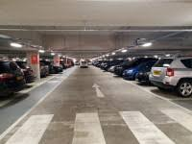

### **Automated Robotic Parking System**

Preethi Ram's 2007 book "An Automated Robotic Parking System A Solution to Urban Parking Problems" provides an in-depth look of the potential applications of automated robotic parking systems for resolving parking issues in urban settings. The advantages of robotic parking systems are emphasized by the author, including their capacity to optimize land use and lessen traffic congestion. The technical features of robotic parking systems, such as their construction, use, and upkeep, are also covered in the book. Ram highlights the security and safety aspects of these systems along with their ability to lower carbon emissions and make cities greener. Examples of successful robotic parking system installations in diverse urban environments are included in the book's case studies.

### **Smart Car Parking System**

The 2016 paper "*Smart Car Parking System for Heterogeneous Clustered Environments*" by Akinpelu and Kennedy Chinedu Okafor promotes the Smart Car Parking System (SCPS) in Port Harcourt, Nigeria, by means of a quantitative statistical survey analysis. The study emphasizes how SCPS can be used to manage parking in dense urban settings, with an emphasis on enhancing traffic flow and easing congestion. The results v important information for next parking management systems and highlight the advantages of deploying SCPS, such as improved efficiency and safety.

### **Car Parking: Impacts, Policy and Practice**

A quantitative statistical survey analysis is used in the 2016 paper. “*Car Parking: Impacts, Policy and Practice*" by Elizabeth J Taylor (2018) provides an overview of over parking, housing, and land use, which are all intricately related, as Taylor's research show. She draws attention to the difficulties in regulating parking in a city that is expanding quickly and the requirement for laws that strike a balance between the interests of various parties, such as residents, automobile owners, and city planners with a focus on Melbourne, Australia. The book also addresses the shortcomings of the parking laws that are in place today and the need for a more comprehensive approach to urban planning.

## **Emerging Trends and Patterns in the research**

Emerging trends and patterns in car parking management systems include the adoption of smart parking technologies, real-time data, and mobile applications to improve parking efficiency and convenience. Automated parking systems, Parking-as-a-Service (PaaS), and the Internet of Things (IoT) are also transforming the parking industry. These trends offer benefits such as increased efficiency, real-time data analytics, and improved security, while also promoting sustainable parking practices and supporting integration with other modes of transportation. Overall, these trends are shaping the future of parking management systems and urban mobility.

Incorporating these **emerging trends** into your car park management system proposal will help demonstrate how your system aligns with current technological advancements and future urban mobility needs. By focusing on **smart technology, sustainability**, and **user experience**, your system can address key challenges in modern parking management and offer a solution that is both efficient and scalable.

**Mobile App-Based Solutions:**  Mobile apps are becoming an essential part of car park management, allowing users to locate available spaces, book spots in advance, and make payments via their smartphones. Integration with **mobile payment systems** like *M-Pesa*, credit/debit cards, and QR codes is common.

**Contactless Payment Solutions:** Contactless payments, including mobile wallet apps and **RFID tags**, are gaining popularity due to their convenience and speed. These solutions reduce the need for physical cash and are particularly useful in high-traffic areas.

**Real-Time Parking Data and Analytics:** Parking management systems are evolving from simple space allocation to more **data-driven solutions**. Real-time data on parking space availability, parking duration, peak usage times, and revenue generation can be analysed to improve decision-making and operations.

**Dynamic Pricing Models:** Dynamic pricing involves adjusting parking rates based on factors like demand, time of day, and event schedules. This trend helps optimize parking space usage and generate more revenue while ensuring fair pricing for users.

**Automated Parking Systems (APS):** Automated parking systems are becoming more common in modern urban areas. These systems use **robotics** and **automation** to park vehicles without human intervention, making use of space more efficient and eliminating the need for wide parking aisles.

## **Research gap filled by the research**

Research gaps in car parking management systems can include:

1. Lack of integration with other transportation systems
2. Limited use of real-time data and analytics for decision making
3. Insufficient consideration of environmental impact and sustainability
4. Inefficient management of peak demand and surge pricing strategies
5. Limited exploration of emerging technologies and trends, such as autonomous vehicles and electric charging stations
6. Inadequate user interfaces and mobile applications for ease of use

Future research in car parking management systems can focus on addressing these gaps to enhance the overall parking experience for drivers, optimize parking space usage, generate revenue, promote sustainable transportation, and improve traffic management in urban areas.

## **Chapter Summary**

The literature review for the car parking management system discusses the features of existing parking systems, their types, and their modes of operation. It highlights the problems in current parking systems, such as congestion, limited parking spaces, and inefficient use of space. The review suggests potential solutions, including the implementation of smart parking systems, real-time information sharing, and dynamic pricing strategies. The review also emphasizes the need for sustainable transportation initiatives and the integration of parking systems with other modes of transportation. Overall, the literature review supports the development of a more efficient and sustainable car parking management system.

# **CHAPTER 3: RESEARCH METHODOLOGY**



## **Introduction**

In the previous chapter we had a general overview of different ways of creation of digital car parking management system. In this chapter we establish research methodology to test the hypotheses and research questions. This commences a brief investigation into the different use-cases to identify research methodologies from similar aligned domains. Software engineering requirements are considered in this context in the design of the system which leads into a discussion of suitability of research outcomes of the study.

This chapter is crucial in defining the approach, techniques, and tools used to gather and analyse data, ultimately leading to valuable insights for the development of the system. Our research methodology will consist of a three-step process, which includes a comprehensive literature review, empirical data collection, and analysis. This systematic and holistic approach will ensure a strong foundation for the research, enabling the investigation of various aspects of car parking management system.

Furthermore, primary data collection will be performed through the use of various techniques, such as questionnaires and interviews. This will allow for the direct input and perspective of the various stakeholders, ensuring that the research encompasses their needs, preferences, and perceptions.

The data analysis process will be carried out using both quantitative and qualitative techniques to ensure that the wide range of collected data is effectively and systematically evaluated. This will involve the usage of appropriate data analysis software and tools, resulting in accurate and informative findings.

In sum, this research methodology chapter is designed to provide a comprehensive and clear overview of the methods and techniques employed, thereby ensuring that the research is rigorous and delivers valuable insights for the car parking management system.

## **Methodology for Requirement Elicitation**

### **Requirement Specifications**

**Functional Requirements**

**Parking Space Allocation:** The system should be able to allocate parking spaces to cars based on availability and the type of parking permit or payment. This may involve integrating with sensors or other hardware to detect when a space is occupied or vacant.

**Payment Processing:** The system should be able to process payments for parking, including accepting various forms of payment such as cash, credit card, or mobile payments. It should also be able to issue receipts and track payment history.

**Access Control:** The system should be able to control access to the car park, including granting or denying entry based on permits or payment status. This may involve integrating with access control hardware such as gates, barriers, or license plate recognition systems.

**Permit Management:** The system should be able to manage parking permits, including issuing, renewing, and revoking permits as needed. It should also be able to track permit holder information and permit status.

**Reporting and Analytics:** The system should be able to generate reports and analytics on car park usage, revenue, and other key metrics. This can help car park operators make informed decisions about pricing, staffing, and other operational factors.

**User Interface:** The system should have a user-friendly interface that allows users to easily find and reserve parking spaces, make payments, and manage their permits. It should also provide clear instructions and feedback to users throughout the parking process.

**Security:** The system should ensure the security of user data and transactions, including protecting against unauthorized access, data breaches, and other security threats.

**Non functional Requirements**

**Performance**: The system should respond to user actions within a very short time typically milliseconds and can handle a certain number of cars entering/exiting per unit time which is the throughput.

**Reliability:** The system should be available for use majority of the time and ensure the system still works even if some components fail.

**Usability**: The system should be user friendly for the drivers and administrators, ensure it can be used by drivers with disabilities which is it is simple and uses both voice and touch to operate.

**Maintainability**: The system should be designed in a modular fashion, allowing for easy updates and modifications to accommodate changing requirements.

### **Data collection and Analysis Techniques**

Effective data collection and analysis is essential for understanding user needs and preferences on a good car parking management system. We will explore some of the techniques that will be used.

* *Questionnaire*

Questionnaires provide structured insight into users' preferences, behaviours, and expectations regarding a car park system. Creating a questionnaire for a car parking management system involves gathering insights from stakeholders to understand their needs, preferences, and requirements. They gather quantitative and qualitative data efficiently, aiding in understanding diverse user needs, such as convenience, safety, accessibility, and environmental concerns. This facilitates informed decision-making and ensures the system aligns with user requirements.

* *Interviews*

Interviews are essential in gathering insights for a car park management system's development. They enable understanding of user needs, preferences, and pain points. Interviews provide firsthand information crucial for designing user-friendly interfaces, optimizing features, and ensuring the system meets real-world demands effectively, enhancing its overall usability and functionality. By asking open-ended questions, developers can uncover nuanced insights and uncover potential issues that users may face. This information is invaluable for designing user-friendly interfaces, optimizing system features, and ensuring the overall usability and effectiveness of the car park management system. Overall, interviews provide a rich source of qualitative data that can inform the design and development of a car park management system, ensuring that it meets the needs and expectations of its stakeholders effectively.

## **Methodology for system analysis**

This explains the method to be used to analyze the system to ensure data flow is appropriate.

### Data Flow Diagrams

Data flow diagrams are graphical representations used to illustrate the flow of data within a system.

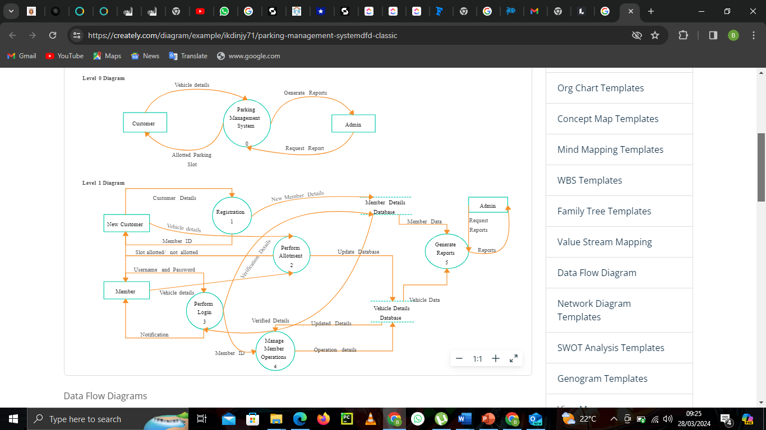

Figure 1 dfd diagram level 0

Source: creately.com

Figure 2 dfd diagram level 1Figure 3 dfd diagram level 0

Figure 2 dfd diagram level 1

Figure 4 dfd diagram level 0

Source: creately.com

Figure 5 dfd diagram level 1Figure 6 dfd diagram level 0

**Figure 1**

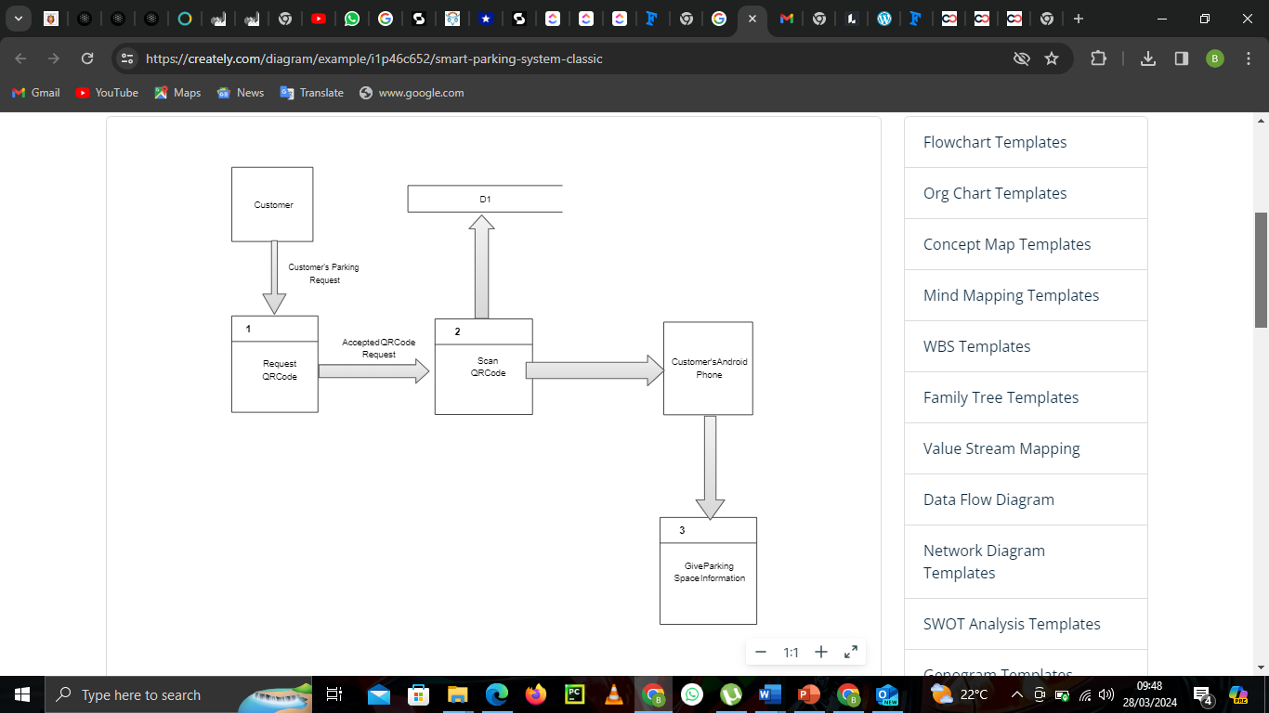

Figure 2 dfd diagram level 1

Source: creately.com

Figure 3 dfd diagram level 2Figure 2 dfd diagram level 1

Source: creately.com

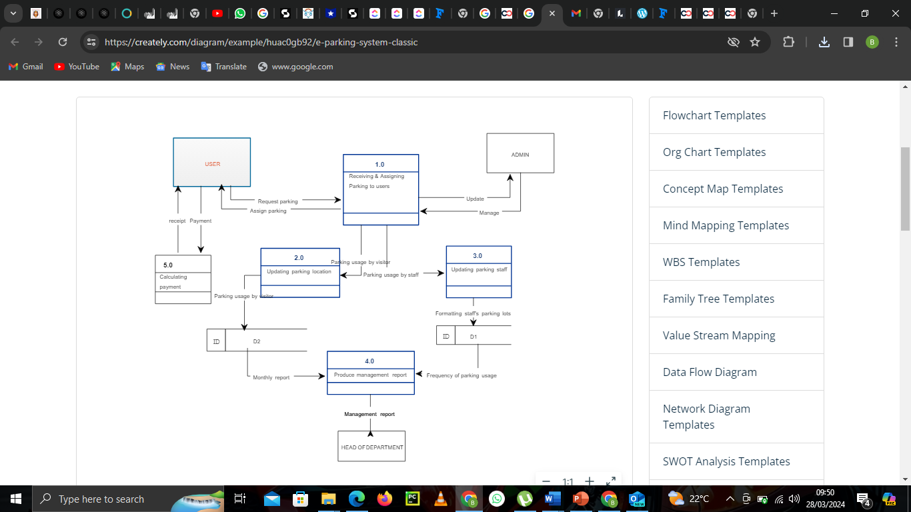

Figure 3 dfd diagram level 2

Source: creately.com

Figure 3 dfd diagram level 2

Source: creately.com

**Context diagrams**

Context diagrams provide an overview of the system's interactions with external entities, showing inputs, outputs, and high-level processes.

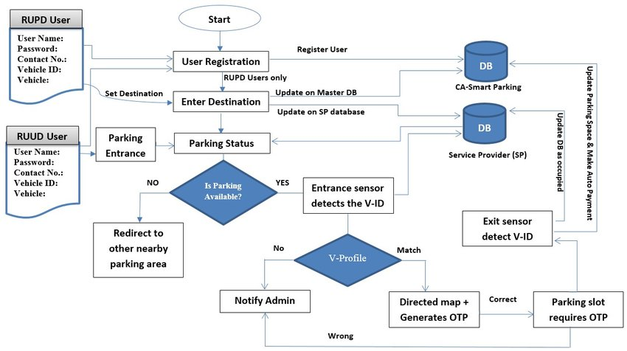

Figure 4 context diagram

Figure 7 database diagramFigure 4 context diagram

**Flow chart**

Flowchart diagrams illustrate the sequential flow of processes, decisions, and actions within a system or process. They depict the logical sequence of steps, decision points, and outcomes, aiding in understanding, analysis, and documentation of procedures.

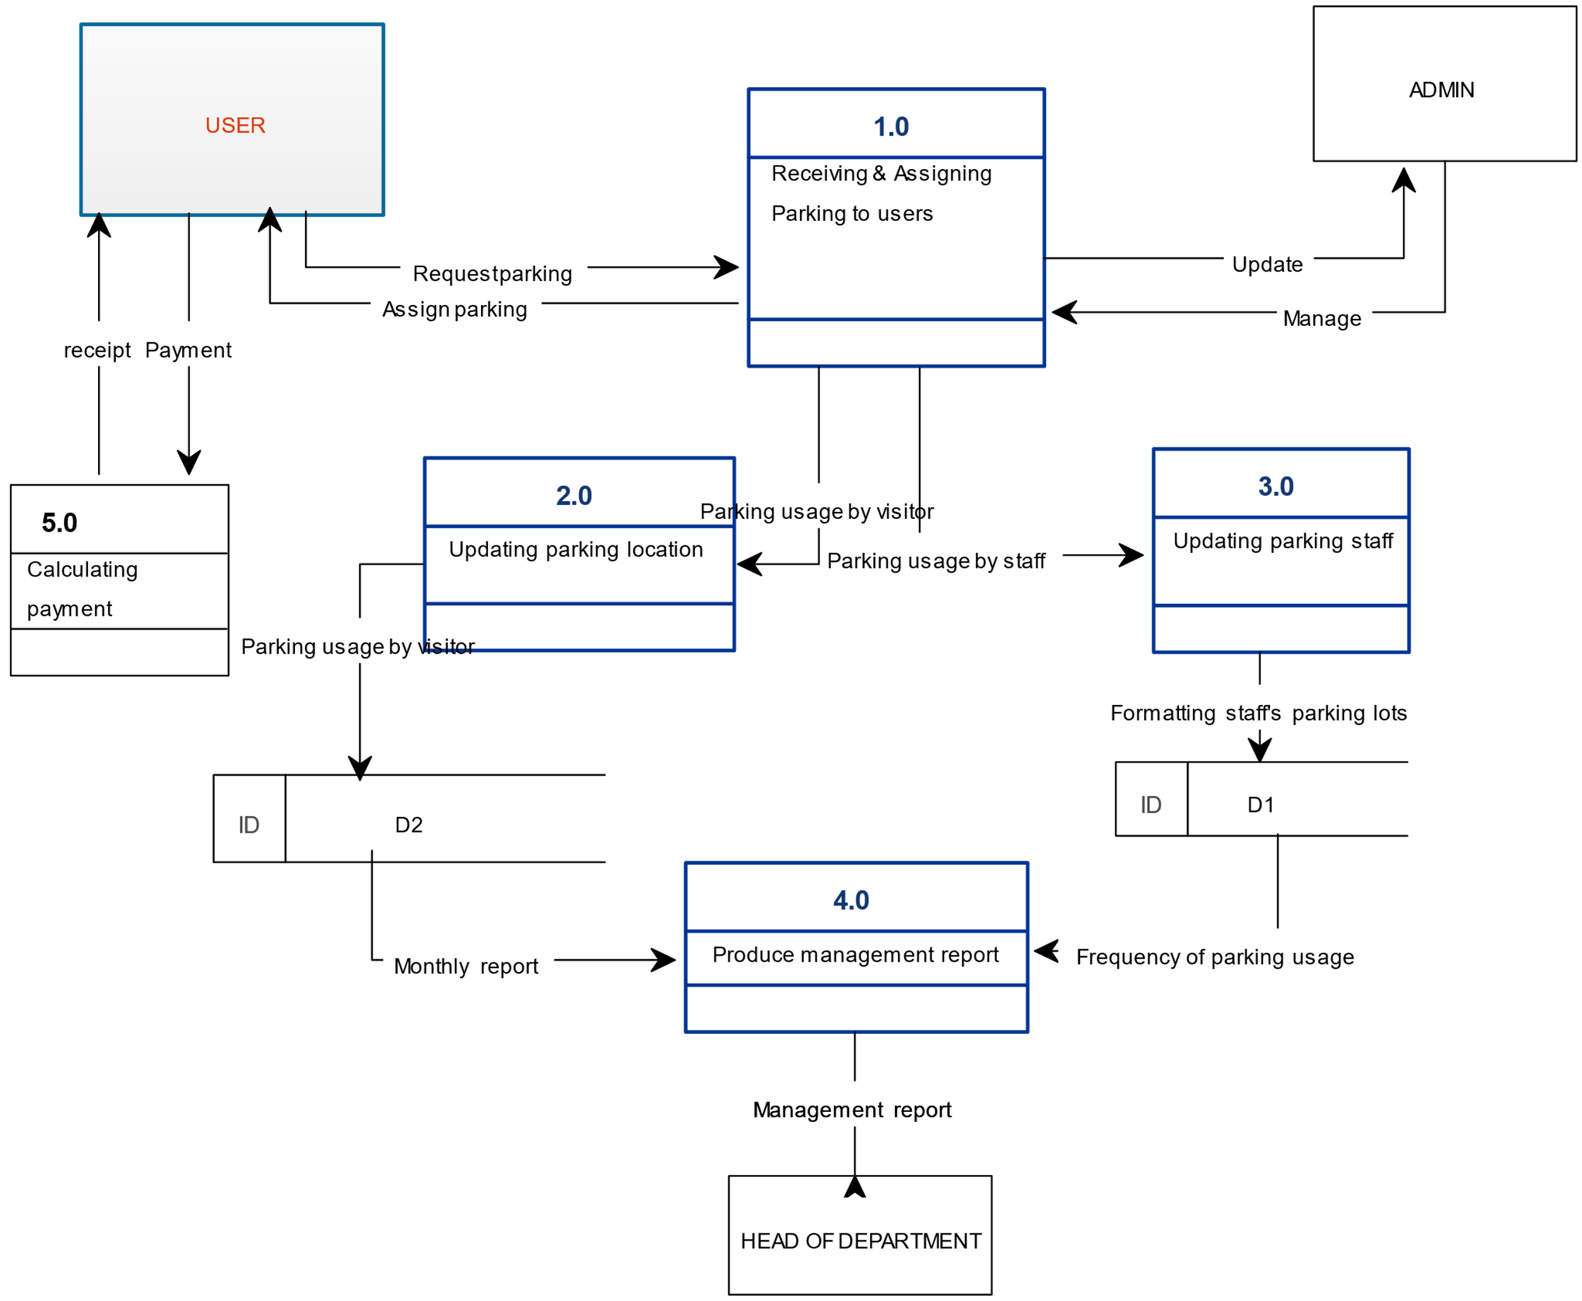

Figure 8 flowchart diagram

## **Methodology for system design**

### Work flow diagram

Workflow diagrams depict the sequence of tasks, actions, or steps involved in completing a specific process or project. They illustrate the flow of work, roles, responsibilities, and decision points, helping to streamline processes and improve efficiency.

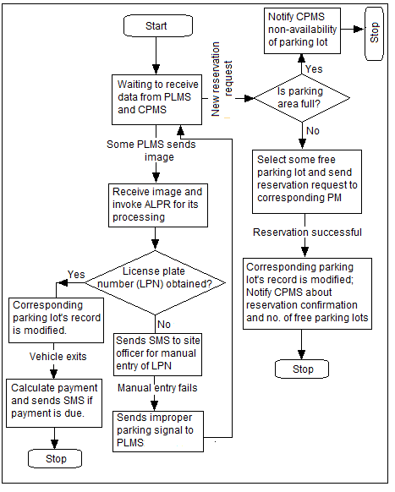

Figure 9 work flow diagram

### Database Design

Database diagrams visually represent the structure of a database, including tables, relationships between tables, keys, and attributes. They help in understanding database schema, designing and optimizing database structures, and communicating database concepts effectively.

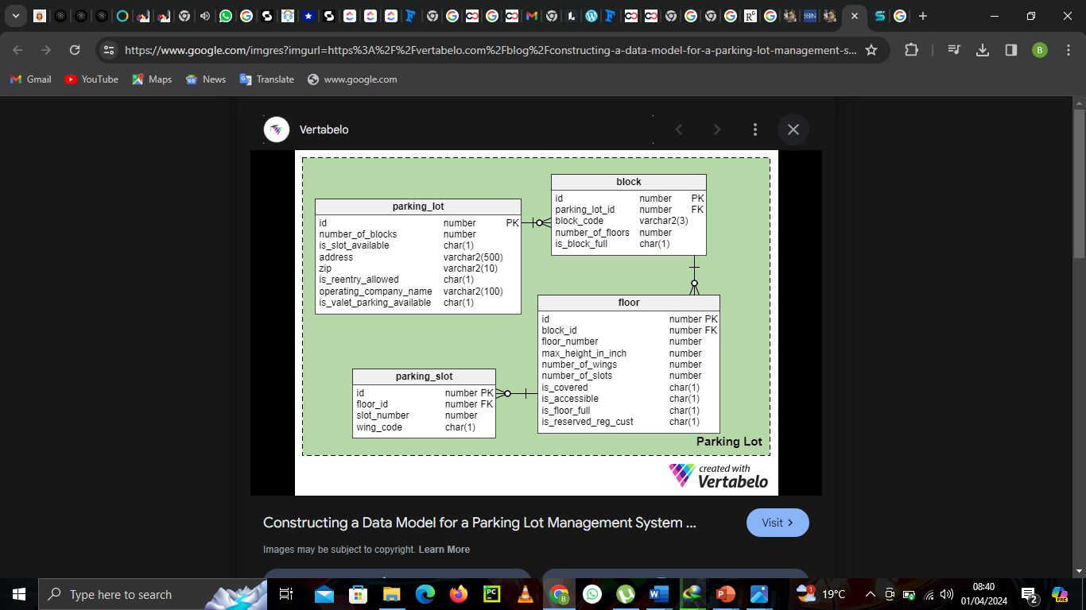

Figure 10 database diagram

3.5.3 Use-case Diagram

### Sequence diagram

Sequence diagrams illustrate the interactions between objects or components in a system over time. They show the sequence of messages exchanged between these entities, aiding in understanding the dynamic behaviour and communication flow within the system.

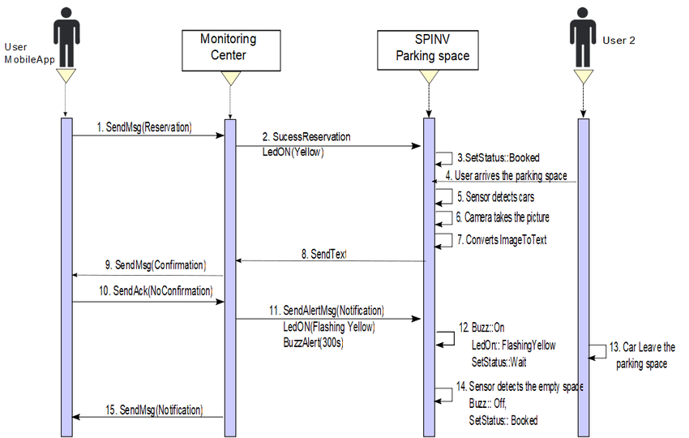

Figure 11 sequence diagram

### Collaboration diagram

Collaboration diagrams, also known as communication diagrams, depict the interactions between objects or components in a system. They emphasize the relationships between objects and the messages exchanged, offering a visual representation of system collaboration and communication flow.

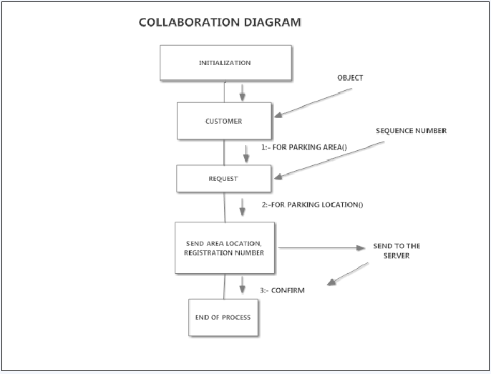

Figure 12 collaboration diagram

### **Pseudo code diagram**

StartTop of Form

Read crossroad ID, Lane direction

Locate the parking space

If (State==1) then

Update the information received in the database

Increment the number of occupied places and decrease the number of available places

Start counting the parking time

If (The RFID tag is detected) then

Update occupied place with RFID data received in the database

Else

Send a message to the parking agents with the identifier of the crossroad and the parking space that has just been occupied

End if

Stop parking time

Calculation of parking fee

End if

Go to 1

### Early system prototypes

## **Methodology for System Implementation**

Implementing a car parking management system requires a systematic approach to ensure the successful development and operation of the car parking management system. This is very essential as it shows how to run and ensure the system operates without any problem. It explains which backend, front end and database tools will be used in creation of the system.

### **Back-end Technologies**

Backend is the server-side of the software that stores and analyzes data, as well as ensuring smooth application performance. We can use the following technologies to implement the back end:

* JavaScript: Features: streamlines back-end development for a car park management system. Its unified language for both front and back ends reduce complexity. Its rich ecosystem facilitates rapid development, real-time capabilities, and cross-platform compatibility, offering a versatile and robust solution for building dynamic and scalable car park management systems.
* Python: Features: Python is a versatile and efficient choice for the backend of a car park management system due to its simplicity, scalability, and extensive library support. Its clear syntax allows for rapid development and easy integration with databases, APIs, and web frameworks, ensuring seamless communication between various system components while facilitating maintenance and updates.

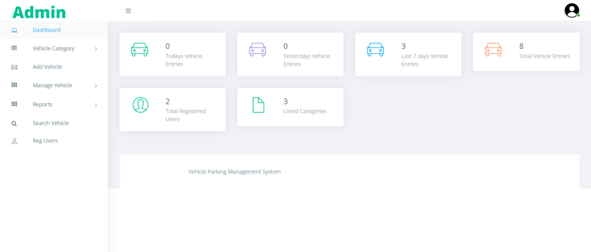

Figure 13 back end

### Front-end Technologies

These are a set of technologies that are used in developing the user interface of web applications and webpages. With the help of front-end technologies, developers create the design, structure, animation, and everything that you see on the screen therefore user friendly. We can use the following technologies to implement the front end:

* Hyper Text Markup Language (HTML): This designs the system that the user will interact with. It should be simple, precise and use simple common language to enable many users to use it.
* Cascading Style Sheets (aka CSS): This will be used to make the system look beautiful and attractive. It makes the design look real and enables user be able to identify the feature they want to use quickly as it defines the various fonts and colours.
* JavaScript Programming Language: Its unified language for both front and back ends reduce complexity. Its rich ecosystem facilitates rapid development, real-time capabilities, and cross-platform compatibility, offering a versatile and robust solution for building dynamic and scalable car park management systems for example use of buttons.

### **Databases Technology**

Database technology take information and store, organize, and process it in a way that enables users to easily and intuitively go back and find details they are searching for. It come in all shapes and sizes, from complex to simple, from large to small.

For our system will use **Firebase Database** as it enables to offers advanced features such as ACID compliance, data encryption, and backup/recovery solutions, essential for managing critical parking data effectively. Its support for complex queries and large datasets enables efficient data processing, while its reputation for reliability and performance ensures uninterrupted operation, making it an ideal choice for mission-critical applications like car park management.



Figure 14 database technology

Figure 15 database

## **Methodology for System Testing**

System testing is a crucial phase in the software development lifecycle where the entire system is tested As a whole to ensure that it meets the specified requirements and performs as expected. Here's a methodology for conducting system testing:

**Test Planning**: To ensure the sensors, closed circuit television cameras are working properly. To ensure the monitors are able to identify empty and full parking spaces and displaying them to incoming drivers. Develop a test strategy outlining the testing approach, techniques, tools, and resources required. Identify test scenarios and test data that cover the functionality, performance, security, and other aspects of the system.

**Integration Testing**: Conduct integration testing to verify the interactions and interfaces between different modules, components, and external systems. Test data flow, communication protocols, data transformation, error handling, and boundary conditions across integrated components.

**Performance Testing**: Conduct performance testing to evaluate the system's responsiveness, scalability, reliability, and resource utilization under various load conditions. Use tools such as load generators, performance monitors, and profiling tools to measure and analyse system performance metrics.

**Security Testing**: Perform security testing to identify vulnerabilities, threats, and risks related to the system's confidentiality, integrity, and availability. Test for common security issues such as injection attacks, authentication bypass, data exposure, and privilege escalation.

**User Acceptance Testing (UAT)**: Involve stakeholders, end-users, or domain experts in user acceptance testing to validate that the system meets their needs and expectations. Obtain feedback on usability, functionality, and overall user experience to ensure satisfaction and adoption.

**Documentation and Reporting**: Document test results, including test plans, test cases, test data, test logs, and defect reports. Generate test summary reports to communicate the overall quality and readiness of the system for release. Provide recommendations for improvements, optimizations, and future testing efforts based on the findings.

## **Methodology for System Deployment**

It involves the transition of the capability to the ultimate end-user, as well as transition of support and maintenance responsibilities to the post-deployment support organization or organizations.

1. **Coding** This may include developing algorithms for parking space allocation, payment processing, and access control, as well as creating a user interface and integrating with hardware components. Once the code is tested and validated, it is deployed to the car park management system for use.
2. **Building**: involves constructing a comprehensive framework integrating hardware, software, and processes. It emphasizes gradual development, scalability, and adaptability, ensuring efficient utilization of resources and seamless operation of the parking system while accommodating future upgrades and changes.
3. **Testing**: entails rigorous evaluation of software, hardware, and processes to ensure functionality, reliability, and security. It involves various testing stages such as unit, integration, and acceptance testing, aiming to identify and rectify issues prior to deployment, ensuring a smooth and error-free implementation.
4. **Configuring**: entails customizing software and hardware settings to align with specific requirements and optimize performance. It involves tailoring parameters such as pricing structures, access controls, and reporting functionalities to meet the needs of the parking facility, ensuring seamless integration and efficient operation.
5. **Monitoring**: involves real-time observation of system performance, traffic flow, and hardware functionality. It employs tools to track key metrics like occupancy rates, revenue, and equipment status. Continuous monitoring facilitates proactive identification of issues, ensuring prompt resolution and optimal system operation.

## **Chapter Summary**

A car park management system employs several methods to efficiently manage parking facilities. These methods include automated entry and exit systems using technologies such as RFID tags, license plate recognition, or ticket dispensers. Occupancy sensors can monitor parking space availability in real-time, allowing for better allocation and utilization of spaces. Payment methods can range from traditional cash payments to contactless options like mobile apps or card payments. Reservation systems enable users to pre-book parking spaces, reducing congestion and improving customer satisfaction. Additionally, dynamic pricing models adjust parking fees based on demand, encouraging turnover and maximizing revenue. Integration with traffic management systems and smart signage enhances overall efficiency and provides a seamless experience for drivers navigating the parking facility. Effective communication channels, including mobile alerts and signage, keep users informed about available spaces and any relevant updates.

# **CHAPTER 4: SCHEDULE, RESOURCES AND BUDGET**

## Introduction

This chapter outlines the project’s schedule, resources required for successful implementation, and the projected budget. It provides a detailed timeline of activities, the necessary resources, and their associated costs. The effective management of time, resources, and budget is critical to the timely and successful completion of the Car Park Management System (CPMS) project.

## **Project Schedule**

The project schedule defines the timeline for completing each task required to develop and implement the CPMS at Thika Road Mall. A Gantt chart will be used to show the dependencies between tasks and the overall project timeline. The chart below summarizes the key project milestones and their respective time frames:

Table 1: Project Schedule

|  |  |  |  |
| --- | --- | --- | --- |
| **Task** | **Duration** | **Start Date** | **End Date** |
| **Project Planning and Analysis** | 4 weeks | 10th October 2024 | 10th November 2024 |
| **System Design and Architecture** | 8 weeks | 11th November 2024 | 3rd January 2025 |
| **Hardware and Software Procurement** | 4 weeks | 4th January 2025 | 1st February 2025 |
| **Development and Integration** | 8 weeks | 2nd February 2025 | 29th March 2025 |
| **Testing and Debugging** | 1 week | 30th March 2025 | 5th April 2025 |
| **Deployment and Training** | 2 weeks | 6th April 2025 | 19th April 2025 |
| **Final Review and Project Close** | 1 week | 20th April 2025 | 26th April 2025 |

The timeline highlights key activities, from the initial planning phase to the final project close. The Gantt chart and tools like Microsoft Project or Trello can be used for a detailed tracking and monitoring of the project.

## **Project Resources**

The resources required for the successful implementation of the CPMS are divided into human and material categories. Below is a list of key resources needed:

**Human Resources**

1. **Project Manager**
   * **Qualifications**: Bachelor's degree in Information Technology, Computer Science, or related field. 3-5 years of experience in project management.
   * **Role**: Oversee project progress, manage timelines, and coordinate resources.
2. **System Developers (2)**
   * **Qualifications**: Bachelor's degree in Computer Science or Software Engineering. 2+ years of experience in Visual Basic.NET or similar programming languages.
   * **Role**: Develop the software components of the CPMS, ensuring the integration of RFID and other technologies.
3. **Hardware Engineer**
   * **Qualifications**: Bachelor's degree in Electrical or Electronics Engineering. 2-3 years of experience in system hardware setup and troubleshooting.
   * **Role**: Setup and configuration of hardware systems such as RFID, sensors, and security cameras.
4. **Quality Assurance (QA) Tester**
   * **Qualifications**: Bachelor's degree in Information Technology or Computer Science. At least 1 year of experience in system testing.
   * **Role**: Test and ensure the system’s functionality and reliability.
5. **Training Specialist**
   * **Qualifications**: Bachelor's degree in Education or related field. 2 years of experience in developing training programs.
   * **Role**: Develop and implement training programs for mall staff and end-users.

**Equipment and Software Resources**

1. **Computers (4 units)**
   * **Specifications**:
     + Processor: Intel i5 or better
     + RAM: 8 GB
     + Storage: 500 GB SSD
     + Operating System: Windows 10 or higher
   * **Purpose**: For development, testing, and deployment of the CPMS software.
2. **RFID System (4 units)**
   * **Specifications**:
     + Frequency: UHF (860-960 MHz)
     + Communication: Wireless
     + Range: Up to 10 meters
     + Compatibility: Windows and Linux-based systems
   * **Purpose**: For vehicle identification and access control.
3. **Sensors (10 units)**
   * **Specifications**:
     + Type: Ultrasonic or Infrared Sensors
     + Detection Range: 2m-10m
     + Accuracy: 98%
   * **Purpose**: To detect available parking spaces in real-time.
4. **CCTV Cameras (5 units)**
   * **Specifications**:
     + Resolution: 1080p HD
     + Connectivity: Wireless
     + Storage: 500 GB Cloud Storage
   * **Purpose**: For security and monitoring.

## **Project Budget**

The following table summarizes the projected budget for the CPMS project, covering human resources, equipment, and other expenses. Contingency funds are also included to account for unforeseen costs.

Table 2:Project Budget

|  |  |  |  |
| --- | --- | --- | --- |
| **Resource** | **Cost per Unit** | **Quantity** | **Total Cost (KES)** |
| **Human Resources** |  |  |  |
| Project Manager | 150,000 | 1 | 150,000 |
| System Developers | 120,000 | 2 | 240,000 |
| Hardware Engineer | 100,000 | 1 | 100,000 |
| Quality Assurance Tester | 90,000 | 1 | 90,000 |
| Training Specialist | 80,000 | 1 | 80,000 |
| **Equipment and Software** |  |  |  |
| Computers | 50,000 | 4 | 200,000 |
| RFID System | 30,000 | 4 | 120,000 |
| Sensors | 15,000 | 10 | 150,000 |
| CCTV Cameras | 25,000 | 5 | 125,000 |
| **Miscellaneous** |  |  |  |
| Software Licensing (VB.NET) | 50,000 | 1 | 50,000 |
| **Contingency Fund (10%)** |  |  | 171,500 |
| **Total Cost** |  |  | **1,226,500** |

The total cost for the project is **KES 1,226,500**, including a contingency fund to manage unexpected expenses.

## **Chapter Summary**

This chapter has outlined the schedule, resources, and budget required for the development and implementation of the Car Park Management System at Thika Road Mall. The project schedule has been carefully planned, with each task allocated a specific time frame. The resources, both human and material, are identified, including the necessary qualifications and specifications for equipment. The budget has been prepared with careful consideration of all components, including a contingency for unexpected costs. These elements are crucial for ensuring the project's success and timely completion.



## **References**

"An Automated Robotic Parking System: A Solution to Urban Parking Problems" by Preethi Ram (2007) discusses the potential of automated robotic parking systems as a solution to parking problems in urban areas.

"Car Parking: Impacts, Policy and Practice" by Elizabeth J Taylor (2018) provides an overview of car parking policy and its relevance to various issues in transport and urban planning, with a focus on Melbourne, Australia.

"Underused Residential Parking Spaces: Environmental Implications and Alternative Uses" by Brenda Vale and Iman (2015) examines the environmental impact of underused residential parking spaces and alternative uses made of garages.

"Smart Car Parking System for Heterogeneous Clustered Environments" by Akinpelu and Kennedy Chinedu Okafor (2016) presents a quantitative statistical survey analysis conducted in selected metropolitan cities in Port Harcourt, Nigeria, to create awareness on Smart Car Parking System (SCPS) for heterogeneous clustered environments.

"The Role of Intelligent Transportation Systems in Urban Parking Management: A Review" by Sanjit Kaul (2009) provides a review of the role of intelligent transportation systems in urban parking management.



## APPENDIX

### QUESTIONAIRE

Creating a questionnaire for a car parking management system involves gathering insights from stakeholders to understand their needs, preferences, and requirements. Here's a sample questionnaire:

General Information*:

Name of the respondent:

Contact Information:

Age range:

Gender:

Location:

Current Parking Situation:

How often do you use parking facilities?

On average, how much time do you spend searching for parking?

What are the biggest challenges you face when parking your vehicle?

Usage Patterns:

What times of day do you typically use parking facilities?

Do you usually park for short-term or long-term durations?

Do you prefer reserved parking spaces or open parking areas?

Payment Preferences:

What payment methods do you prefer for parking fees (e.g., cash, credit/debit card, mobile payment apps)?

Would you be interested in subscription-based parking plans or discounted parking packages?

Are you open to using digital wallets or prepaid accounts for parking payments?

User Experience:

How important is it for you to find parking quickly and easily?

What features or amenities do you consider essential in a parking facility (e.g., lighting, security, accessibility)?

Would you be interested in receiving real-time updates on parking availability and rates?

How do you prefer to receive notifications or alerts about parking-related information (e.g., SMS, mobile app notifications)?

Feedback and Suggestions:

What improvements would you like to see in parking facilities or management systems?

Are there any specific pain points or issues you encounter frequently while parking?

Do you have any suggestions for enhancing the overall parking experience?

Additional Information:

Are there any specific features or functionalities you would like to see in a car parking management system?

Thank you for taking the time to complete this questionnaire. Your feedback is valuable in helping us improve

### INTERVIEW

1. Can you describe your experience with implementing or managing car park management systems?
2. What are the key components or features you believe are essential in a car park management system?
3. How do you ensure the security and integrity of data within the car park management system, especially regarding user information and payment transactions?
4. Can you explain your approach to optimizing parking space allocation and minimizing congestion within a car park using management systems?